**GIS and remote sensing for conservation and evolutionary biology**

**Sessions 7: computer lab exercise**

**Aim:** To run ENMTools to compare overlap between two species’ Maxent models.

_____________________________________________________________________________

**We strongly suggest doing this lab in R, using the accompanying R script for session 6. If you choose not to use R, then:**

First, make sure you have downloaded and installed ENMTools software in your Windows environment <http://www.danwarren.net/enmtools/builds/ENMTools_1.4.4.zip> , and the manual (for reference, if needed): <http://www.danwarren.net/enmtools/ENMTools_User_Manual%201.0.pdf>

After downloading, you will also need to download and install ActivePerl and TK+. Go to <http://www.activestate.com> choose languages -> ActivePerl. And download and install the standard distribution (for windows). Try to open ENMTools.pl (by double-clicking). If it doesn’t work, you may need to install the newest TK+ distribution. Launch the perl package manager (go to the start menu folder that was created during the perl installation), scroll to the TK+ package and right click on install. See the ENMTools manual for how to do this (page 3).

You may also want to look at the Warren et al. 2008 and 2010 papers describing the software package for further background (a PDF of these papers are in the Session6_data folder on the course webshare).

______________________________________________________________________________

**ENMTools** is (was) a perl-based software package that compares Maxent models to one another by measuring model overlap. The advantage of ENMTools is its null model approach, which allows you to measure the statistical significance of model overlap values.

For this lab, **everyone is required to do the Identity test in ENMTools (Part A)**.

However, if your individual project includes comparing the maxent models of two or more species/populations, we highly recommend you also do the Background test (Part B), although this part of the lab is optional (it is time-consuming). In addition to these two tests, ENMTools also includes a range-break test and other geographic boundary tests. Refer to the ENMTools manual or the Glor & Warren 2011 paper in the Session6_data folder for information on these other tests. We also provide information on other similar tests to ENMTools that you can run in R, and if you are interested in running ENMTools in R rather than the GUI you can also do that.

**Part A. Testing for niche equivalency: The identity test.**

First, create “Inputs” and “Outputs” folders inside the ENMTools folder for data management. **Mac users: Within the “Outputs” folder, add a new folder named “plots”**. We recommend you keep this folder (which includes the software program) on your desktop. Then, collect the data you’ll need and copy and paste these data into the ENMTools folder. *ENMTools often does not run when input files are outside of the ENMTools folder*

These are the **data you’ll need**. You can either use data from your independent project, or the canned dataset (lemurdata.zip) in the Session6_data folder on the course webshare.

1. Two maxent model probability surface outputs in ascii grid format, representing two different species or populations in the same study area.

Ideally, these should be two final model outputs for two different species or populations of interest to your project. They should have been created with the same set of environmental layers, but with different .csv occurrence files (representing the two different species’ occurrence records). If you are only looking at one species for your project, or if you do not yet have final maxent model outputs for two species from your project, you can use the canned dataset in the webshare (E_m_flavifrons.asc and E_m_macaco.asc).

1. Two .csv text files representing the occurrence localities for the two species in question.

These should be in exactly the same format for .csv for input to maxent. If you are using the canned data from the course webshare, these files would be e_m_flav.csv and e_m_maca.csv

1. Climate/environmental layers in ascii grid format

Include an internal folder in the Inputs folder with all of the environmental layer inputs that were used to generate the maxent models in (1). If you are using the canned data from the course webshare, these files would be in Lemur_layers.zip.

Once you have your input data gathered and in the appropriate folder, open up the ENMTools software exe file.

**Configure ENMTools**

Go to the options tab, and choose ENMTools options. Choose climate layers as the source for climate data. Then set the layers directory to the folder where you put your environmental layers (3 – above). Also set your output directory. Set the location of your Maxent .jar file, and set the suitability measure to logistic. Say no to show the maxent gui. Your maxent version is 3.3 or newer. Click the “save options” button.

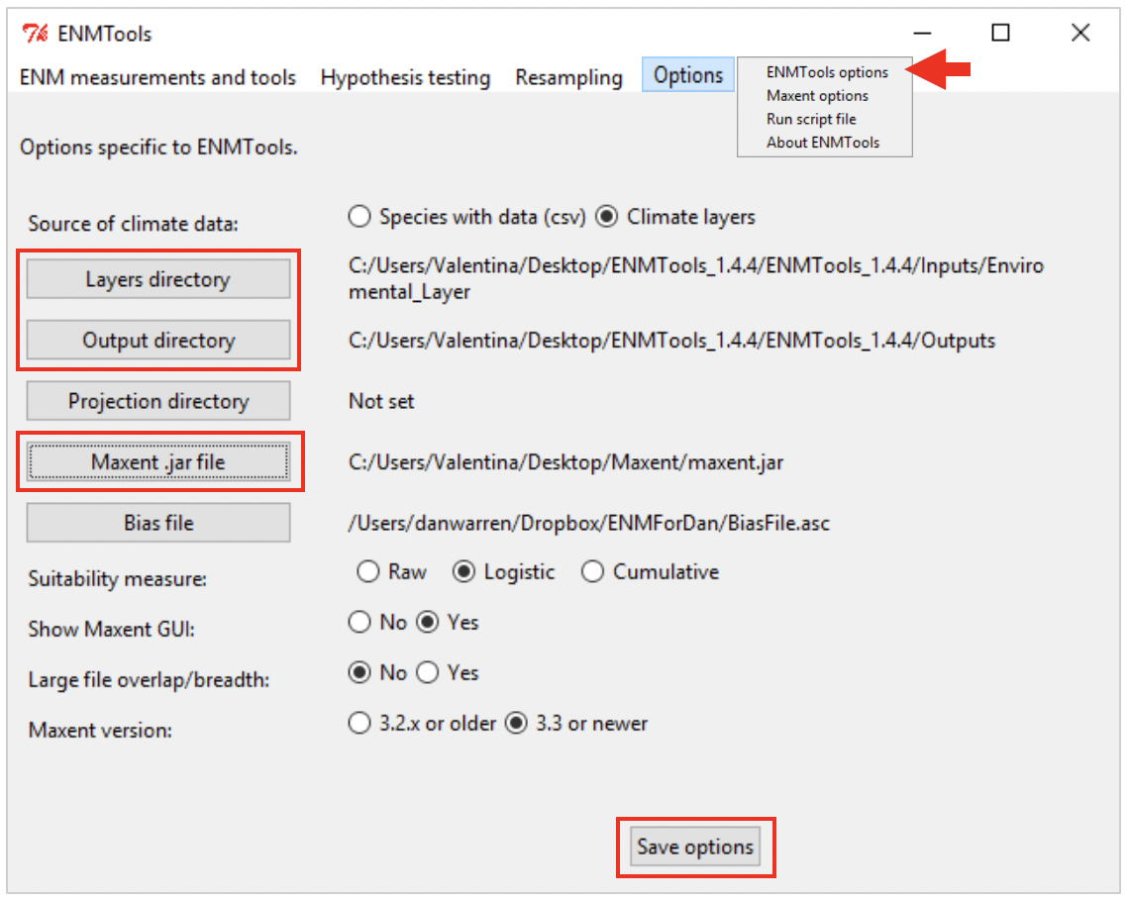

Now, choose Maxent options under the options tab. Choose no for all of the questions (to speed up the process). If you say yes to remove duplicates, make sure you have separate output folders for separate runs to avoid overwriting previous results files. Set the regularization parameter to the optimal parameter for your species. The “RAM to assign to Maxent” option requires an argument of the form –mx####m, where #### is the number of megabytes of RAM that you want Maxent to use. Make sure that it doesn’t exceed the amount of memory available on your system.

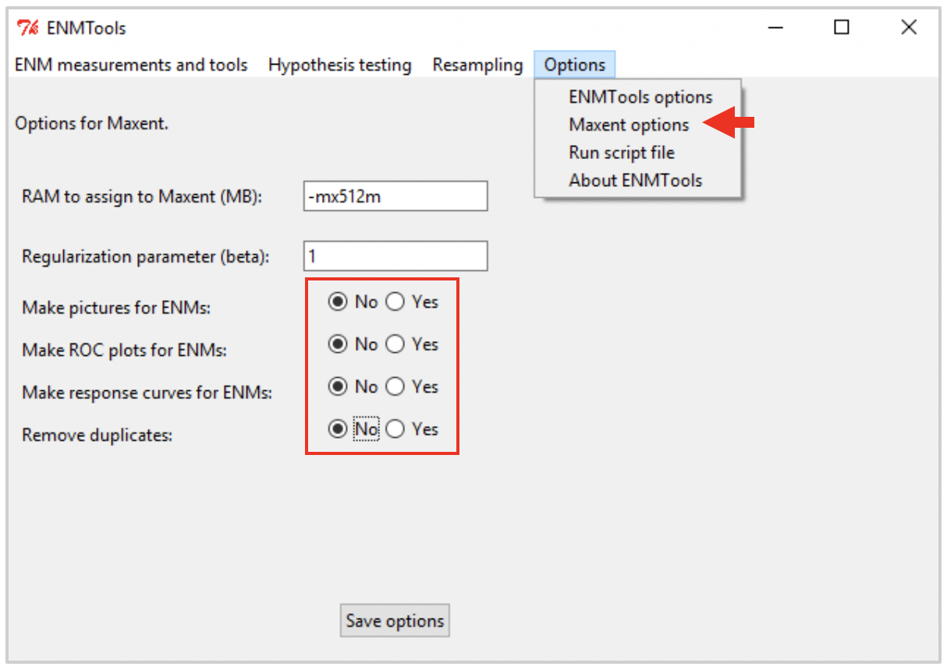

**Measure Model Overlap**

-Go to ENM measurements and tools> Niche overlap (ASCII files).

-Click Add files and navigate to the ascii model output files from #1 (above).

-Name the analysis after the two species you are looking at. And click Go!

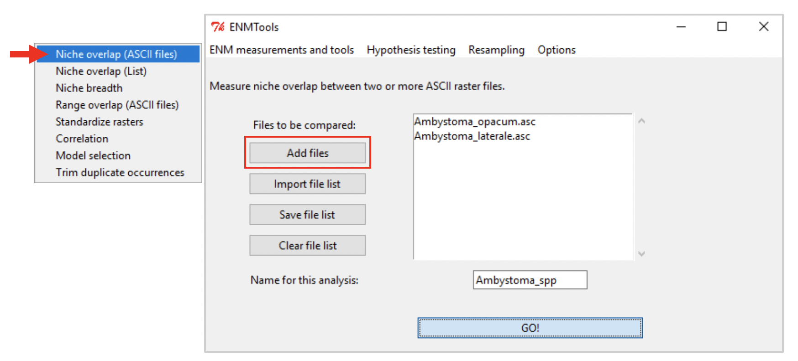

In the output directory you will see three .csv files. Open these files in excel. You will see that the program generated three values, these are I, D, and rr statistics of niche overlap. **Record these “true overlap” values** for I and D. Schoener’s *D* and Hellinger’s *I* are the most commonly reported overlap measures (rather than rr). You can read more about these measures in Warren’s papers. D has a biological interpretation (about habitat use), while I does not. You may use either or both statistics in your study.

**Note:** You can also quickly measure niche overlap using these statistics in the ENMeval R package: <http://cran.r-project.org/web/packages/ENMeval/index.html> (Muscarella et al. 2014)

**Run the Identity test**

To test for niche equivalency between the two models, the identity test in ENMTools creates pseudoreplicate datasets by randomly partitioning the occurrence records for two species into sets where the species id’s are mixed up (formally, for a pair of species with *nx* (*ny*) occurrences of species *X* (*Y*) they randomly partition the pooled set of *nx* + *ny* into sets of size *nx* and *ny*). Then, the test builds ‘pseudoENMs’ in Maxent based on the pseudoreplicates and the climate layers you specified. Finally, it calculates *I* and *D* overlap metrics between each pair of pseudoreplicate models. They advocate using 100 replicates, which will mean an output of 100 overlap values (a null distribution), which you can then compare to the ‘true’ niche overlap value that you measured above using a one-sided test for significance.

-Go to Hypothesis testing>Identity test

-Input the two csv files of occurrence localities for your two species of interest (#2 from above). If a space appears above the first entry, clear the file list and start again.

-Say that you want to run 100 replicates. Check run maxent. Click Go!

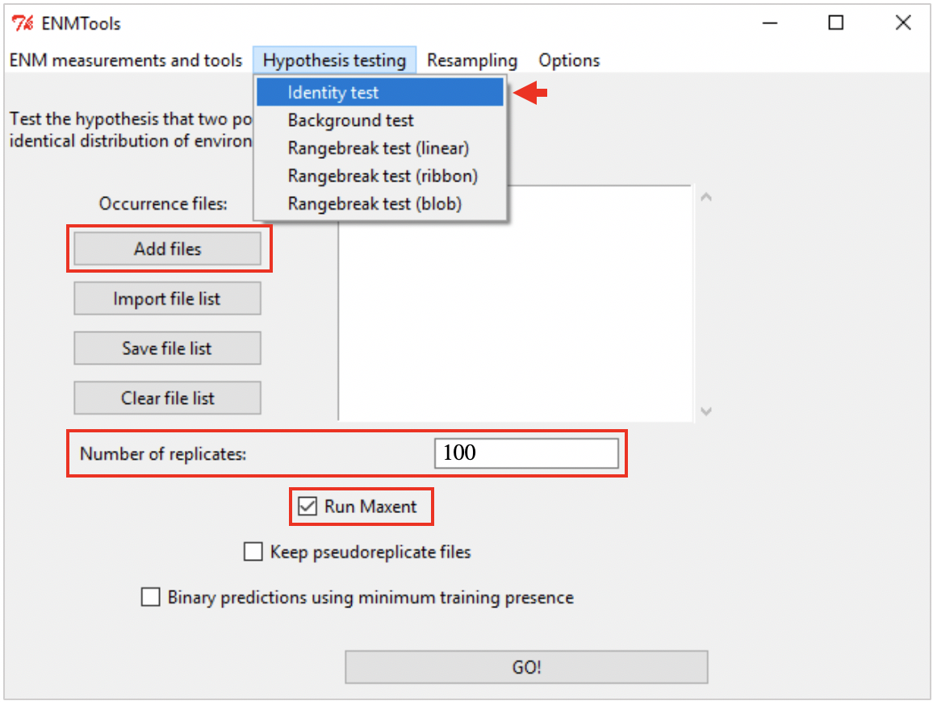

After the test is complete (it may take about 20 minutes to run), in the output directory you will see a .csv file with IDENTITY in the title and SORTED at the end. Open this file in excel. You’ll see columns for the overlap values of I and D for the 100 replicates.

Now, go back find the “true” model overlap values that you measured above. Your task is to figure out whether the true overlap value (for I or D) falls **below** the 95% confidence interval for the null distribution (of I or D). Since there are 100 values in the null distribution and the file has these values pre-sorted, you can easily see if the true value is less than the top three values in the file.

To more easily visualize your results, you can use the Histogram feature in excel under data analysis to see where your true overlap value falls on the null distribution, e.g.:

Description: Macaco&FlavifronsMTP.pdf

If you’d like, you can also use R for a more rigorous significance test, where mu is the true overlap value being tested, e.g.

wilcox.test(IDENTITY_speciesA_vs_speciesB_sorted$I,alternative=”greater”,mu=0.403985)

**Part B. (OPTIONAL) Testing for niche similarity: The background test.**

This test compares the ‘true’ model overlap with what is expected given the environmental conditions available to each species. It is therefore a more theoretically robust null model than the Identity test you performed in Part A. As mentioned above, if your individual project includes your comparing the Maxent models of two or more species, we recommend you also do the background test for greater statistical and theoretical rigor. But keep in mind, this test may take up to 1 hour or more to run (and even longer to prepare the data needed beforehand).

**Note:** The ENMTools background test has advantages, but recently, other similar tests have been argued as even more robust for hypothesis testing. For example, the Broenniman et al. 2011 method (see a PDF in the Session6_data folder) compares niches in multivariate space without the assumptions inherent in running a niche model first.

First, you’ll need to generate additional input data:

Or, if you just want to try this out “for fun” rather than with your own data, – you can use the canned dataset in the course webshare. The two additional files you’ll need for this test are E_m_maca_rndm.csv and E_m_flav_rndm.csv. In that case, skip to step 5 below.

The additional data you need to generate for this test are **random “background” points** for each species. These random points should be drawn from an area that represents the geographic range or area available to each species in question – so, it should be smaller than the size of the environmental layers used to generate your maxent models.

Most people do this by creating a minimum convex hull around the occurrence localities, and then drawing random points from within that polygon. We describe how to do this below.

**If you are concerned about sampling bias in your occurrence records, instead of a convex hull, you could use IUCN range shapefiles as your background areas (<http://www.iucnredlist.org/>) and sample random points within those polygons instead.

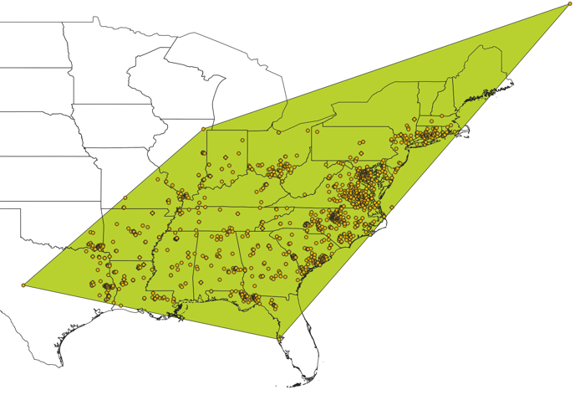

1. Create a Minimum Convex Polygon around your occurrence points for each species:

Open a new QGIS map document. Add the two species’ .csv files using the *Add Delimited Text Layer* button. Go to **Processing** toolbox and click on **Toolbox**. In the Processing Toolbox search window, type in the word “convex”. Under *Vector geometry ,* click on ***Minimum bounding geometry***

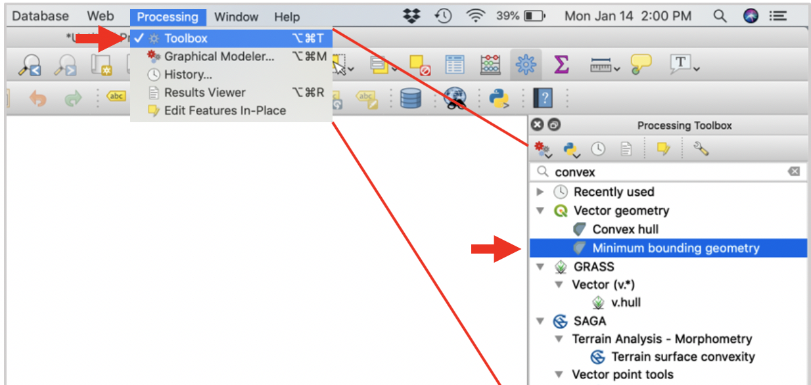

Input one .csv layer at a time. Use Geometry type **convex hull**.

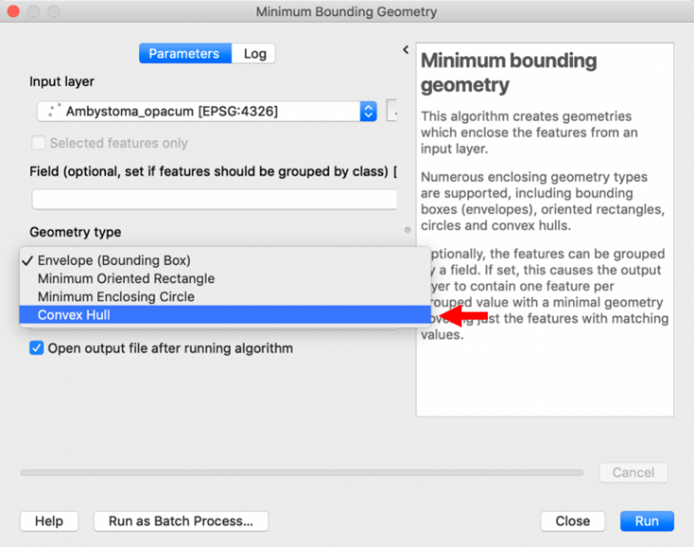

Repeat this for the other species’ shapefile.

**Note:** It is important to check if this polygon runs over into an ocean (or onto land if you are modeling a marine species) – if so, you will need to convert the one of the environmental rasters to a polygon, then use this polygon to clip the MCP. **Raster > Conversion > Polygonize (raster to polygon).** Then, **Vector > Geoprocessing Tools** > **Clip**. Input layer is the MCP layer, and the clip layer will be polygonized raster.

2. Create random points

Go to **Vector > Research tools** > **Random Points in Layer Bounds**.

Specify an output location and feature class name. The constraining feature class is the polygon you created just now. For the number of points, use 100 times more points than you have occurrence records. So, if you have 8 occurrence records, create 800 random points (however, its likely unnecessary to go above 5,000 depending on the extent of your area).

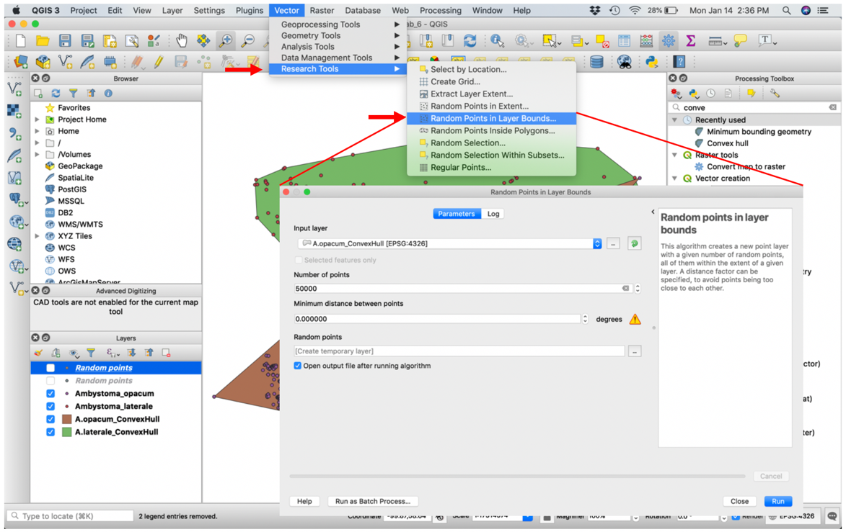

Repeat for the other species’ polygon.

3. Add XY coordinates

Your background shapefiles should be loaded on the map. To save these files as .csv, right click > Save as… > change the Format to Comma Separated Value [csv]. Repeat for the other species’ random points shapefile.

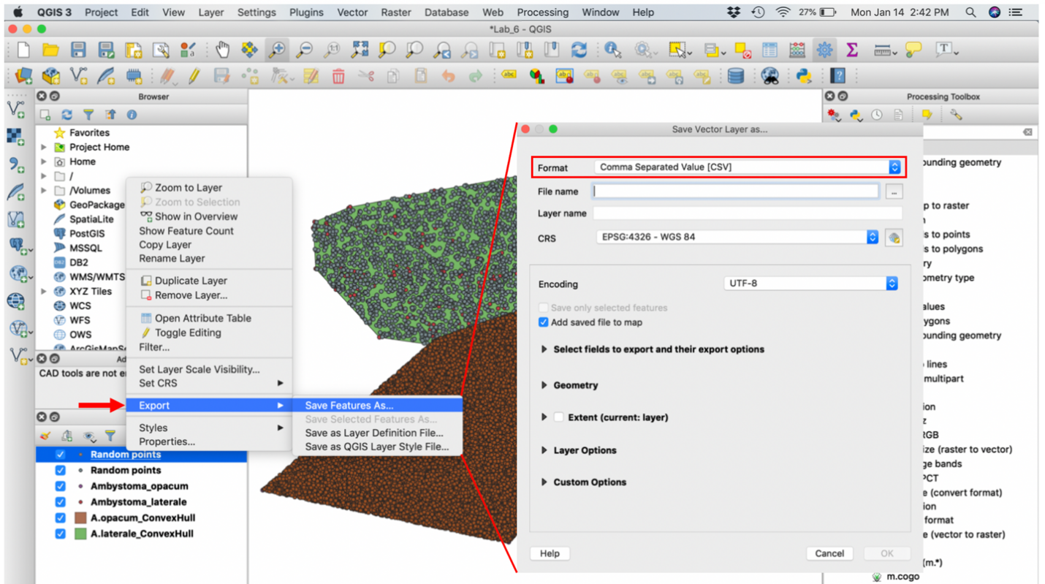

4. Run background test

-Place your new random background point .csv files in the ENMTools Inputs folder you created at the beginning of the lab.

-Open ENMTools

-Load your focal species occurrence csv file (the true occurrences for Species A) and then load the background samples csv file (random points) for Species B. Specify 100 replicates and the number of background samples (this should be equal to the number of true occurrences for Species B: ENMtools will draw this number of occurrences from the random points as a psuedoreplicate). Click “add this analysis”.

-Now, load the other focal species occurrence csv file (true occurrences for Species B) and the background samples csv file for Species A. Specify 100 replicates and the number of background samples (the number of true occurrences for Species A). Click “add this analysis”.

-Make sure run maxent is checked and hit Go!

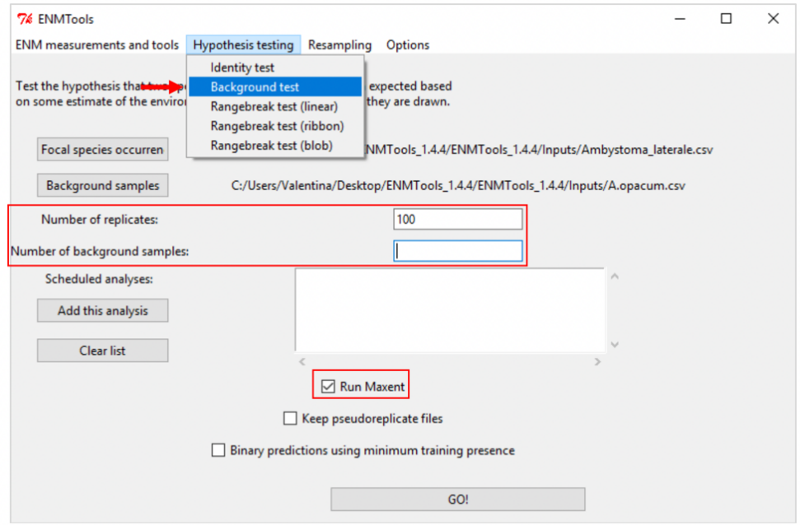

Depending on how big your study area is and the processing speed of your computer, this may take up to 1 hour.

After the test is complete, in the output directory you will see two .csv files with BACKGROUND in the title (one for each direction of the test). Open these files in excel. You’ll see columns for the overlap values of I and D for the 100 replicates, just like for the identity test. Again, go back find the “true” model overlap values that you measured above. Your task is to figure out whether the true overlap value (for I or D) falls **above or below** the 95% confidence interval for the null distribution (of I or D). If the true overlap value is above the interval, the species models were more similar than you would expect based on the area available to them (**niche conservatism**). If below, the species’ models are more different than you would expect based on the area available to them (**niche divergence**).

As with the identity test, to more easily visualize your results, you can combine the background results into one excel document and use the Histogram feature in excel under data analysis to see where your true overlap value falls on the two null distributions, e.g. (for niche divergence):



If you’d like, you can also use R for a more rigorous significance test, where mu is the true overlap value being tested, e.g.

wilcox.test(BACKGROUND_speciesA_vs_speciesB_rndm$I,alternative=“two-sided”,mu=0.403985,conf.level=0.95)

wilcox.test(BACKGROUND_speciesB_vs_speciesA_rndm$I,alternative=“two-sided”,mu=0.403985,conf.level=0.95)

Note that this is a two-sided test, while the identity test was a one-sided test. Also, note that you need to perform two tests (one in each direction). A t-test may also be appropriate here (instead of a wilcoxon), assuming a normal distribution (use same code but with t.test at the beginning).